**EXPERIMENT 11**

**Aim:** Study of BPSK Modulation and Demodulation Process.

**Required:**

1. ST8335/CY1802E Trainer Board with power supply cord
2. Oscilloscope with connecting probe
3. connecting cords

**Connection Diagram:**

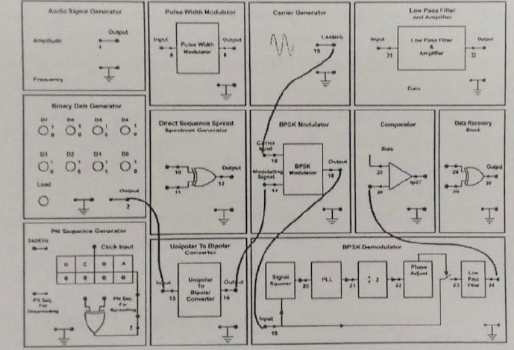

**Waveforms:**

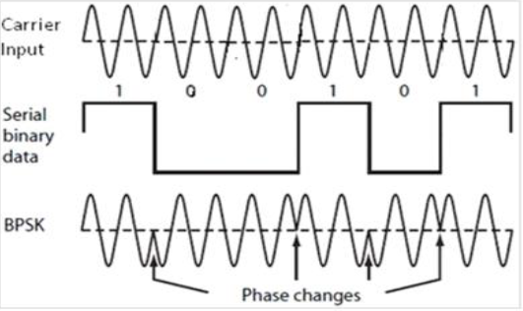

**Procedure:**

1. Before making connections, make sure that power supply is switched off.
2. Refer to the above while making connections.
3. Connect the output of binary data generator to the input of unipolar to bipolar converter.
4. Connect the output of this converter to the modulating signal input of BPSK modulator.
5. Connect sinusoidal carrier from the carrier generator section to the carrier input of BPSK modulator
6. Turn data switches of binary data generator to '1' or '0' as per your choice of 8-bit Binary data pattern. This binary data generator will then repeat the sequence continuously.
7. Now switch 'On' the power supply and observe me output of Binary Data Generator on the CRO screen. If data is not appearing then press load pushbutton to reset it. Adjust the time base so as to see the complete repetitive binary data. Every bit in this sequence repeats itself after 8 consecutive bits.
8. Observe the output of BPSK modulator on CRO. This is BPSK modulated Waveform.
9. Now connect the output of BPSK modulator to the input of BPSK Demodulator. Connect the output of low-pass filter of BPSK Demodulator to the comparator input.
10. Now observe the output of comparator on CRO. Adjust the bias of comparator and phase of Carrier Recovery circuit of demodulator until you see a complete replica of the input binary data. This is our demodulated signal. It may so happen sometime that the recovered output is an inverted replica of input signal. If such an output comes then readjust the phase of recovered carrier to obtain the correct waveform.

**Waveforms:**

